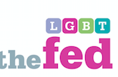
The LGBT Federation North East (The Fed) is a regional infrastructure organisation and I was on the first team of directors. Initially there were no paid workers and the directors were not paid either. I was with The Fed for 16 years (2003 – 2019). Our initial funding was from One North East (ONE) as we represented the “sexuality strand” of the protected equality characteristics.

The first meeting of the sexuality strand was the LBi Group as they were an already established group and registered company with an active Lesbian Line. Next meeting was at the Royal Station Hotel with LGBT People from all over the Region. We split into separate groups of lesbians, gays, bisexuals and 1 transwoman. There was loads of energy in the room and everyone was delighted to be working together. We decided that it would be of benefit to continue working together and that we should plan a Regional Conference to launch this new LGBT organisation.
We had our Regional Conference at the Discovery Museum which was well attended with lots of ideas for the way forward. A steering group was formed to get this regional LGBT organisation launched. It was decided to amalgamate with LBi as one company and change the name to The LGBT Federation North East with LBi Coalition as a separate part with their own management etc.

My involvement during this formation period was through MET
((Management and Equality Training) and because I was a member of this community as a lesbian. MET did the administration for The Fed, wrote the bids for funding, organised the meetings, did all the usual paperwork.
The aims of The Fed were to bring together Lesbians, Gays, Bisexuals and Transgender people to have a strong voice in the Region, to raise the profile and visibility of LGBT people in the Region and to facilitate their participation in Region-Wide events and activities.

Some of the achievements over the years have been:
- Many LGTB people had housing issues so we organised a conference of housing companies and LGBT people to discuss what the housing companies were doing for LGBT communities and to discuss how LGBT people could work with the housing companies to help them make their services LGBT Friendly.
- Having representation on the Police and Crime Commissioners LGBT Panel
- Developing a group of LGBT Volunteers to be advocates for victims of Hate Crime
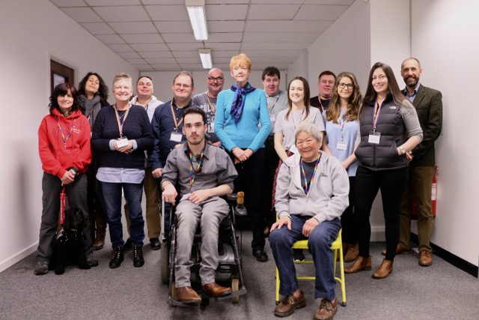

LGBT Volunteers with the Vera Baird the then PCC

- Developing an LGBT Asylum Group to help them achieve refugee status

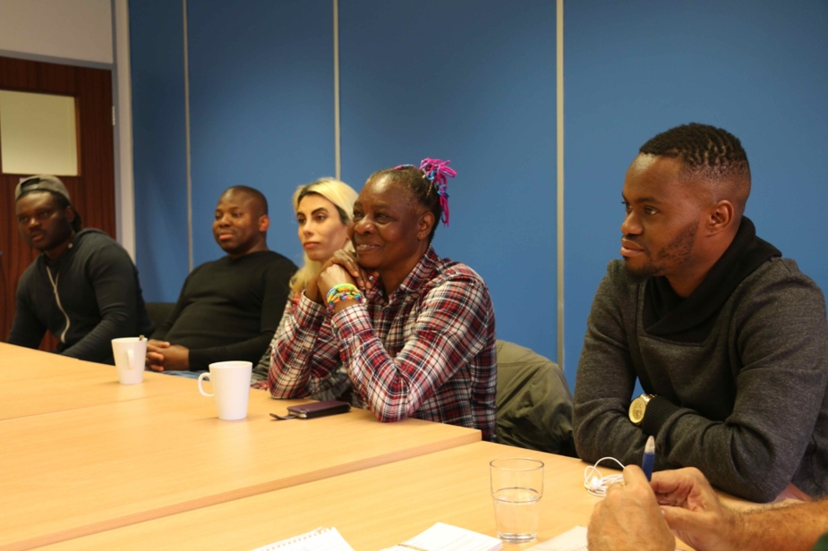

- Staffing a stall at all the Pride Celebrations in the Region

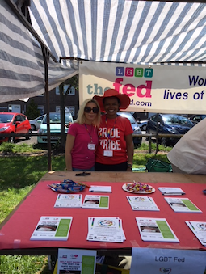

- Facilitating a series of learning sessions such as basic BSL so that hearing members could interact with our deaf members, well being sessions, and IT sessions so that members could make full use of digital services. Louise and Julie signing “lesbian”

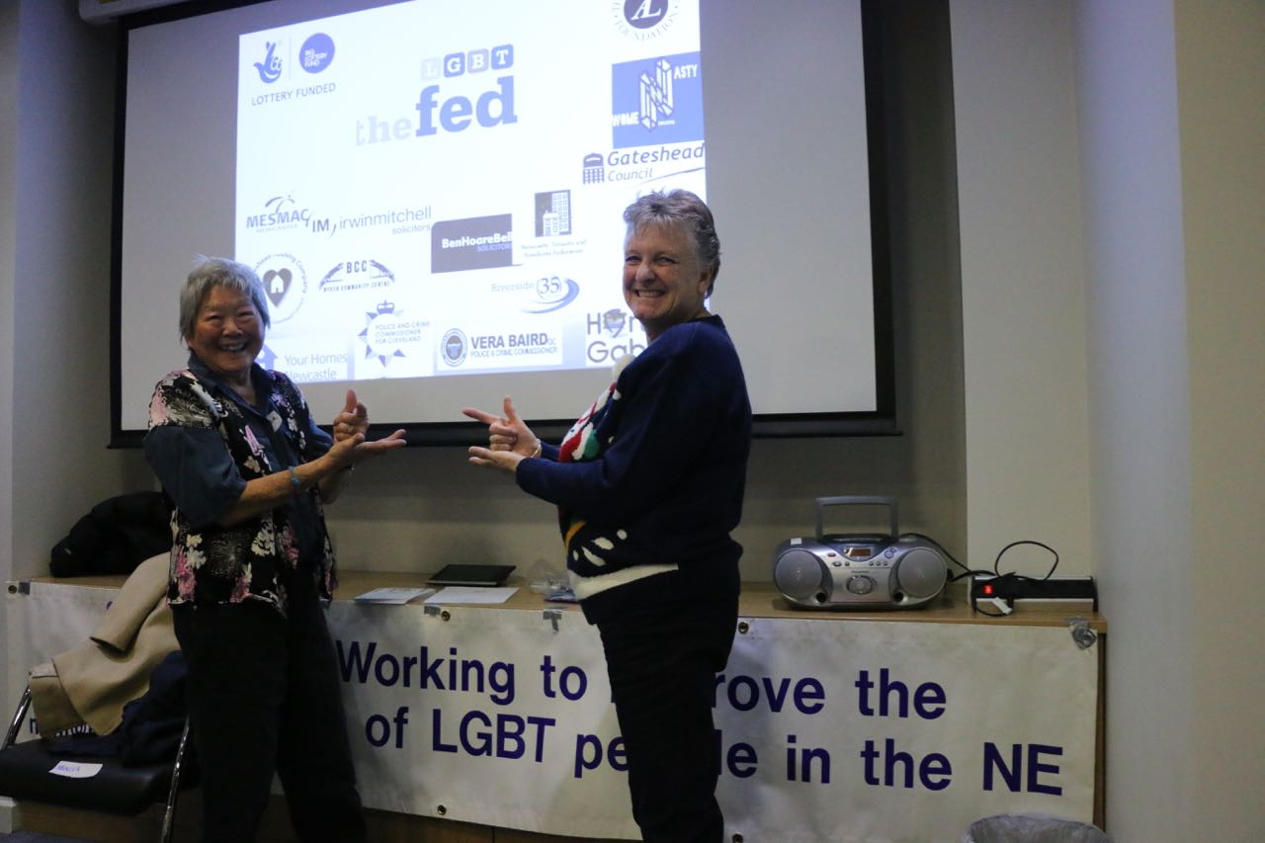
At the AGM we would get members to discuss what they would like to do in the next year and we would do our best to facilitate this.

- Producing an Annual Ball where LGBT people could be free to hold hands and dance together in Public.

- We managed to get funding from the Government to deliver training about awareness of LGBT Hate Crime in schools which was very well received and evaluations were positive.

- We also managed to get coverage of our Hate Crime Awareness Week on TV and Radio

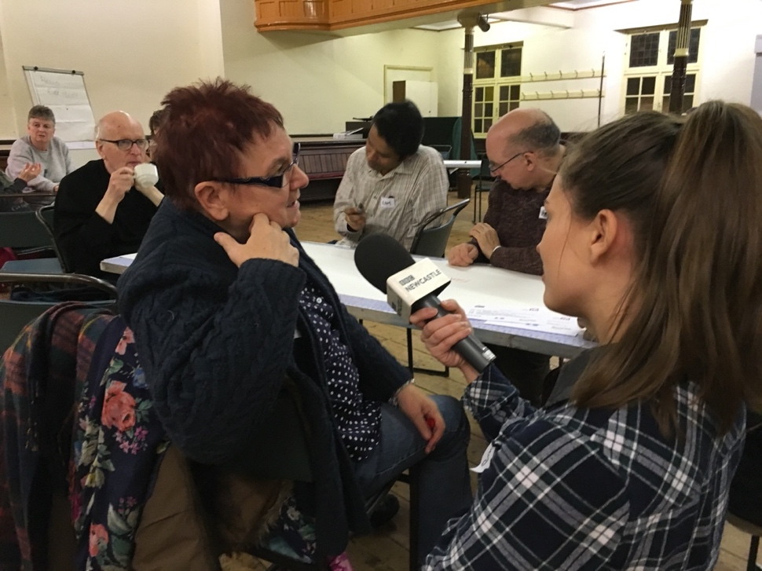

- We also facilitated several Arts Projects such as learning Hiaku poetry with Kath Boodhai and Making Banners for Pride March

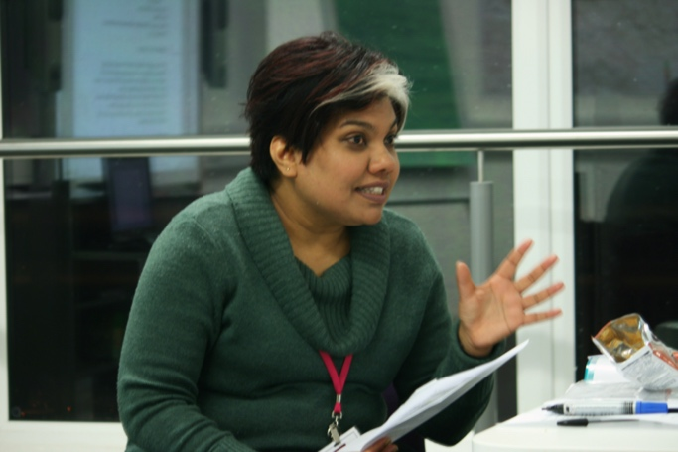
The main impact of The Fed was to bring LGBT people together through shared interests, activities for support, and making us visible in a positive and constructive way to the general public and to service delivery organisations.
Representation on various forums helped get the voice of LGBT people heard.

Volunteers have been the life blood of The Fed. Everything was facilitated by volunteers. Our resident photographer Aleks Dogramadzi was excellent at photographing events and adding them to our web-site www.lgbtfed.com. This really helped members to feel that we exist in this World and that we and our events were noted and important.
Our membership was representative of the population in terms of BME members, and disabled members. This was particularly important because BME Communities and Disabled communities tend to not be LGBT friendly so The Fed was an important support for BME and Disabled LGBT people and vice versa as having such a diverse membership helped keep The Fed current and relevant.

When the Government priorities changed from Regional to Local it became difficult to access funding as a regional infrastructure organisation and The Fed became more of a Project focused organisation but we made sure that the Projects we bid for were in line with our aims. It also meant that we couldn’t make long term plans.

I don’t think there was any one event or experience that had a significant impact on The Fed. Progress for LGBT people is about a change of culture so that we are accepted as LGBT people and this sort of change is gradual and slow. There is definite progress along these lines but life for LGBT people is still not as free as it is for heterosexuals. It is particularly hostile for lesbians to show emotions for each other in Public and doubly so if they happen to also be BME Lesbians. I think that being a Black Lesbian in a prominent role for The Fed helped to encourage other BME LGBT people to come out and to be supported as members.
I resigned before the pandemic so can’t comment on how it has affected The Fed.

I am really happy about this Heritage project and that The Fed has been included as sexuality is a critical part of a person’s identity and if LGBT people are not able to be open about their sexuality it means they can’t be themselves and can’t fully contribute to Society.

