Celebrate AFRICA DAY
With NEEACA

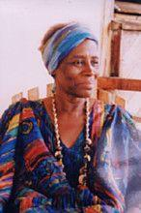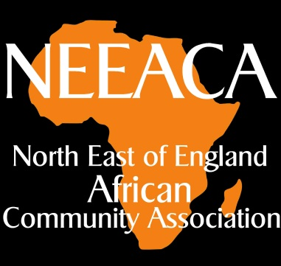
Saturday19th May 3.00 - 7pm
GRACE HALLWORTH, renowned storyteller, author of 16 children’s books, a delight for children and adults alike.

‘Bowery’ Dance Performance by 15 Young North East Dancers,
Gateway Dance Studio

Local Black History, Fred Suadwa
Don O’Mears, Historic England

Our African stories

Preceded by AGM
Forum on policing, PC Barnes
Education and health

Children’s activities, Food, Music
St Teresa’s Church Hall, Heaton Rd, Newcastle NE6 5NQ
Contact:bpg@blueyonder.co.uk

